100. Same Tree
Easy

Given the roots of two binary trees p and q, write a function to check if they are the same or not.
Two binary trees are considered the same if they are structurally identical, and the nodes have the same value.

Example 1:
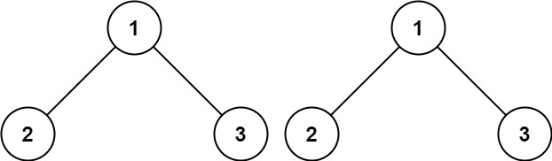
Input: p = [1,2,3], q = [1,2,3]
Output: true
Example 2:
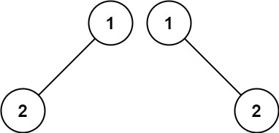
Input: p = [1,2], q = [1,null,2]
Output: false
Example 3:
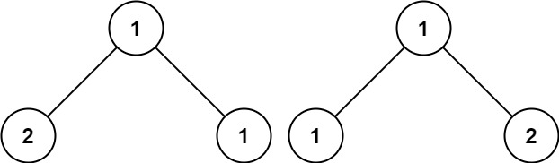
Input: p = [1,2,1], q = [1,1,2]
Output: false

Constraints:
- The number of nodes in both trees is in the range [0, 100].
- -104 <= Node.val <= 104

